- Purpose
  - The purpose of this document is to describe the procedure for assembling a key switch box on a propane machine.
- Scope
  - This SOP applies to all equipment assembly team members. The process applies to the following machines:
E012800EQM0600BE1200 – 21” Optima XR
E012805EQM0600BE1200 – 21” Optima XR w/ Clutch
E012815EQM0600BE1200 – 21” Optima XR w/ Emissions & Clutch
E012830EQM0600BE1200 – 27” Optima XR
E012835EQM0600BE1200 – 27” Optima XR w/ Clutch
E012840EQM0600BE1200 – 27” Optima XR w/ Emissions
E012850EQM0600BE1200 – 27” Optima XR w/ Dust Control
E012860EQM0600BE1200 – 27” Optima XR w/ Clutch & Dust Control
E012865EQM0600BE1200 – 27” Optima XR w/ Emissions & Dust Control
E012875EQM0600BE1200 – 27” Optima XR w/ Emissions, Clutch, & Dust Control
E012327EQM0600BE1200 – Big Bertha XSM30 Propane Stripping Machine Pkg
E088398EQM0600BE1200 – Lil Bertha XSM24 Propane Stripping Machine Package
- Responsibilities
  - The operations manager/supervisor is responsible for enforcing this SOP.
- Materials
  - The proper materials needed for this process are listed on the machine work order.
  - Hand/Power Tools
- Definitions

- Procedure
  - Take a key switch box (86121) and attach the on/off label (10550) to it in the orientation shown.
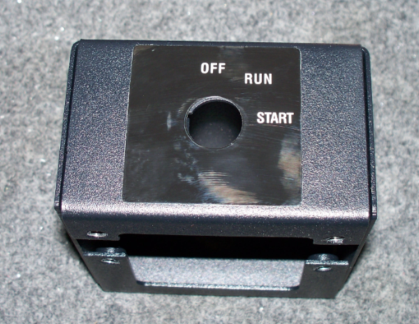
  - Install the wire stabilizer clamp (10204) in the orientation shown on the bottom of the key switch box. Tighten the nut on the inside of the key switch box to secure it. Loosen the 2 screws on the clamp to allow the wires to easily pass through.
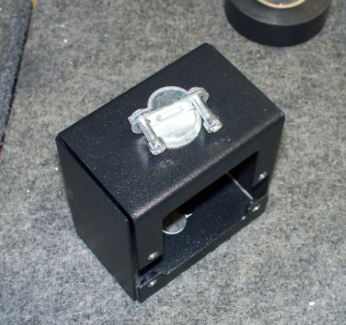

- References (optional section as needed)

- Training Guide

Functional Training Groups Requiring Training
Equipment Assembly Group

- SOP Change Control

Date of Change | Reason for Change
Rev 01 - 11/22/2013 | This is the first version of the S.O.P. hence there are no revisions to this document.
Rev 02 - 1/12/2018 | Added Responsibilities section
Rev 03 - 5/4/2018 | Updated for the Optima XR upgrade
Rev 04 - 3/21/2025 | Remove work center notes. Updated machine ID list in Scope 2.01

Approvals

Submitter/Author Approval:__________________________________ Date:______________________

Management Approval:______________________________________ Date:______________________

QAU Approval:_____________________________________________ Date:______________________

